Project: Predictive Analytics Capstone

## Task 1: Determine Store Formats for Existing Stores

1. What is the optimal number of store formats? How did you arrive at that number?

Thanks to my analysis, I have recognised that the optimal format number is 3. In the assessment report, we can observe that the median is highest for position number 3 for both Adjusted Rand Indices and Calinski-Harabasz Indices.

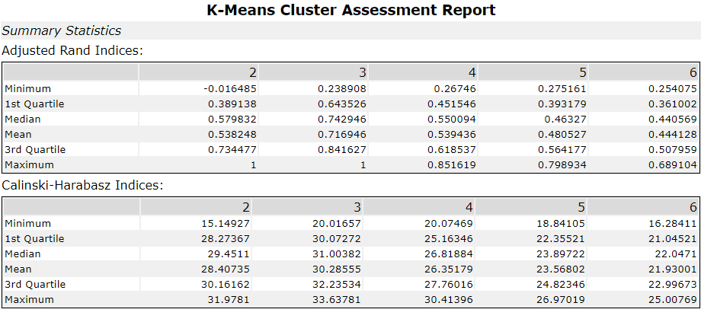

Figure 1. K-Means Cluster Report

From the two plots below, we observe that the Compactness and distinctness have the best value for the number of clusters equal to 3.

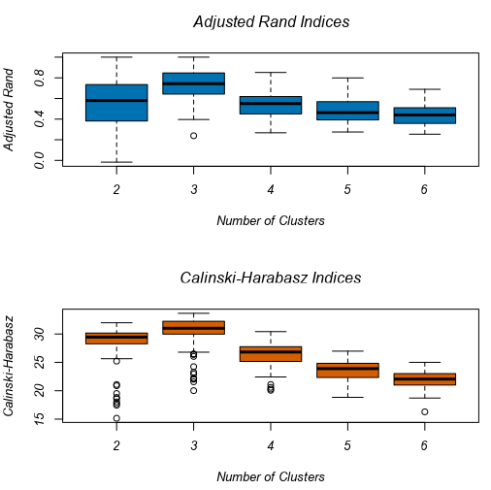

Figure 2. Adjusted Rand Indices and Calinski-Harabasz Indices

1. How many stores fall into each store format?

The number of stores per cluster is displayed below.



Figure 3. Cluster Information

1. Based on the results of the clustering model, what is one way that the clusters differ from one another?

From the K-Centroids cluster analysis how each cluster is build. The more positive number the more sales for this particular product.

* For Cluster 1 the driver is: General Merchandise
* For Cluster 2 the driver is: Production
* For Cluster 3 the driver is: Meat and Deli

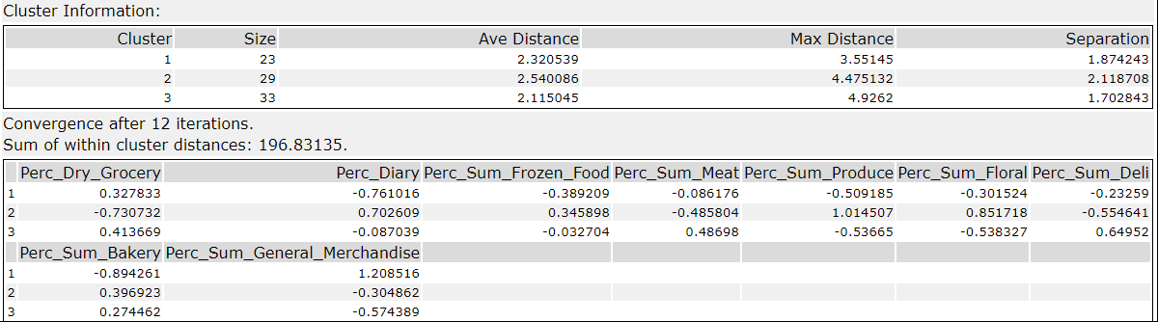

Figure 4. Alteryx K-Centroids Cluster Analysis Result

1. Please provide a Tableau visualization (saved as a Tableau Public file) that shows the location of the stores, uses color to show cluster, and size to show total sales.

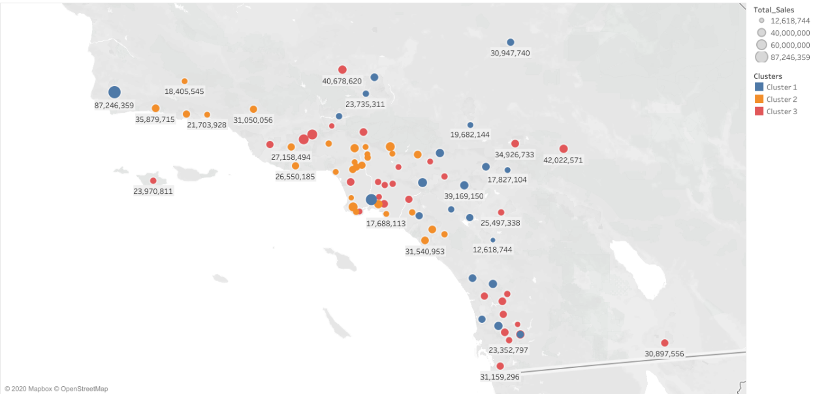

Map 1. Location of the Stores

## Task 2: Formats for New Stores

1. What methodology did you use to predict the best store format for the new stores? Why did you choose that methodology? (Remember to Use a 20% validation sample with Random Seed = 3 to test differences in models.)

The report comparison tool shows the same accuracy for both forest and boosted model. Looking at the F1 measure, we can see it have a slightly higher value than other models. That is why I have decided to use the boosted model.

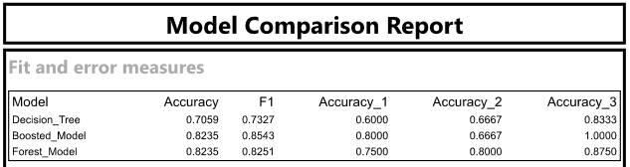

Figure 5. Model Comparison Tool

Using the confusion matrix, we can also observe where the models have been correct and where they didn't predict cluster accurately. From the tables below, we can see that the boosted model predicted cluster number 1 and cluster number 2 100% correctly. It predicted incorrectly 3 positions in cluster 3.

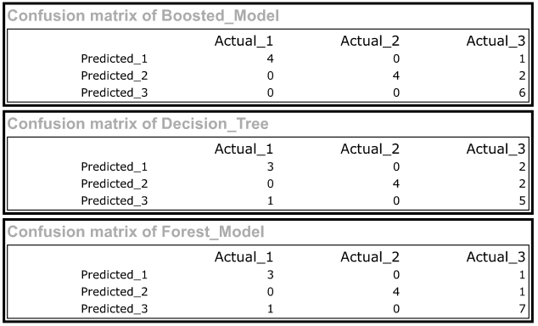

Figure 6. Confusion matrixes of all 3 models

1. What format do each of the 10 new stores fall into? Please fill in the table below.

|  |  |
| --- | --- |
| Store Number | Segment |
| S0086 | 3 |
| S0087 | 2 |
| S0088 | 1 |
| S0089 | 2 |
| S0090 | 2 |
| S0091 | 1 |
| S0092 | 2 |
| S0093 | 1 |
| S0094 | 2 |
| S0095 | 2 |

## Task 3: Predicting Produce Sales

1. What type of ETS or ARIMA model did you use for each forecast? Use ETS(a,m,n) or ARIMA(ar, i, ma) notation. How did you come to that decision?

Using original data dataset, I have compared the performance of ETS and ARIMA model to select which one will be better for forecasting the store's performance.

I have used ETS(M, N, M) without dampening for the ETS model.

The error plot shows variance over the years. It is fluctuating with different seizes; this means we need to use the error multiplicatively(M).

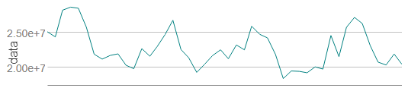

Figure 7. Decomposition Plot – Data Graph

We aren't able to clearly say if there is a pattern in the below data, that is why we have applied neutral trend(N).

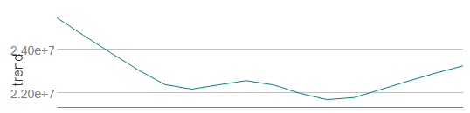

Figure 8. Decomposition Plot – Trend Graph

The seasonal plot shows seasonality in similar periods. That is why I have applied seasonality in the multiplicative method(M).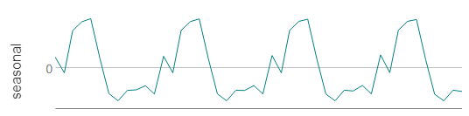

Figure 9. Decomposition Plot – Seasonal Graph

Using a time series plot, we can identify that the plot isn’t stationary, and we will need to apply some changes to it to use the ARIMA model effectively.

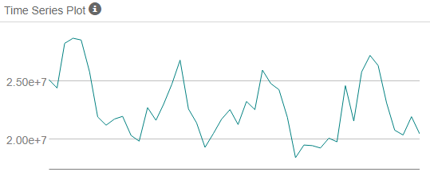

Figure 10. Time Series Plot.

The same is observed on the ACF and PACF function plots. 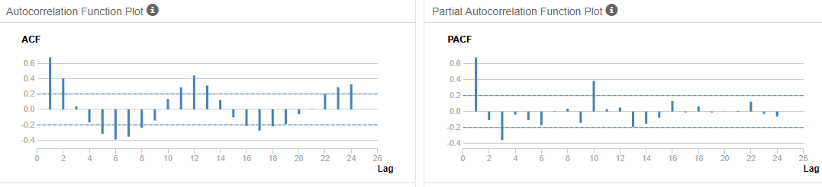

Figure 11. Time Series Plot.

**Using the TS plot, I have discovered that I should use the models with these parameters: (0,1,2)(0,1,0).**

After the two models have been complete, we can compare how good are their predictions.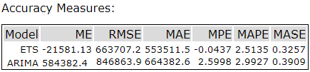

Figure 12. Accuracy Measures – TS Compare Tool Results.

Using the TS compare tool, we have obtained compassion for the two models. ETS model has the best accuracy values. That is why I believe the ETS model to forecast product sales for the new and existing stores.

2. Please provide a table of your forecasts for existing and new stores. Also, provide visualization of your forecasts that includes historical data, existing stores forecasts, and new stores forecasts.

|  |  |  |  |
| --- | --- | --- | --- |
| Period | Sub_Period | New Store Sales Forecast | Existing Store Sales Forecast |
| 2016 | 1 | 2 588 356.56 | 21 829 060.03 |
| 2016 | 2 | 2 498 567.17 | 21 146 329.63 |
| 2016 | 3 | 2 919 067.02 | 23 735 686.94 |
| 2016 | 4 | 2 797 280.08 | 22 409 515.28 |
| 2016 | 5 | 3 163 764.86 | 25 621 828.73 |
| 2016 | 6 | 3 202 813.29 | 26 307 858.04 |
| 2016 | 7 | 3 228 212.24 | 26 705 092.56 |
| 2016 | 8 | 2 868 914.81 | 23 440 761.33 |
| 2016 | 9 | 2 538 372.27 | 20 640 047.32 |
| 2016 | 10 | 2 485 732.28 | 20 086 270.46 |
| 2016 | 11 | 2 583 447.59 | 20 858 119.96 |
| 2016 | 12 | 2 562 181.70 | 21 255 190.24 |

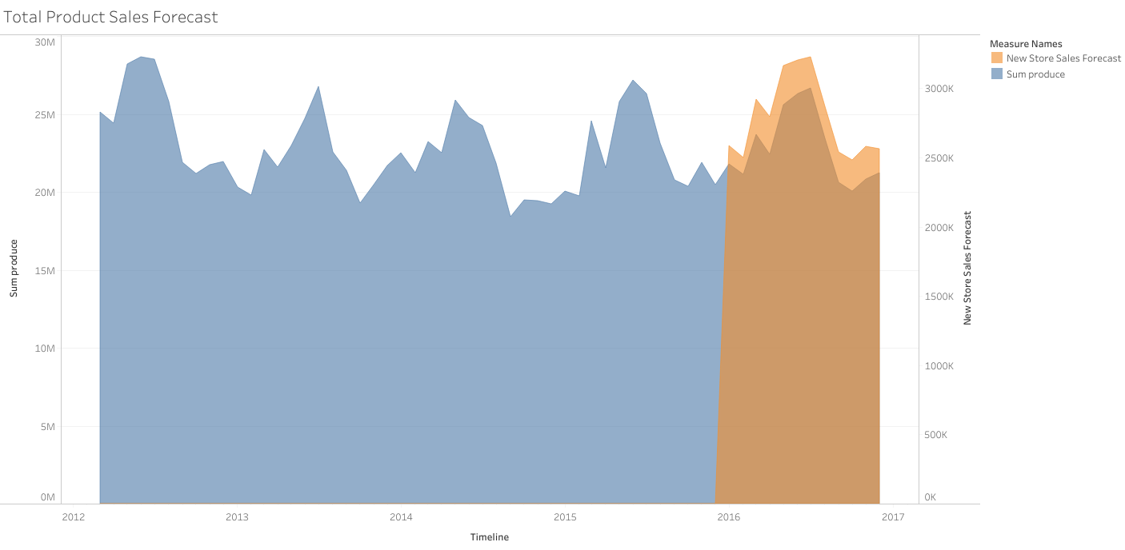

Figure 13. Historical data + Forecast for existing and new stores for the year 2016

# Alteryx Workflows

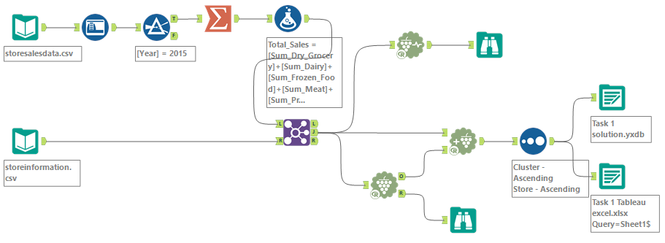

Workflow 1. Task 1: Determine Store Formats for Existing Stores

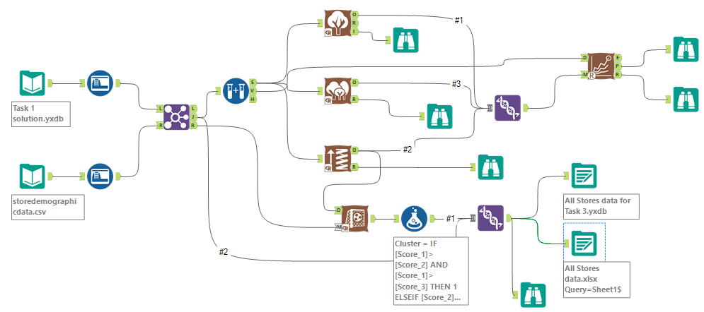

Workflow 2. Task 2: Formats for New Stores

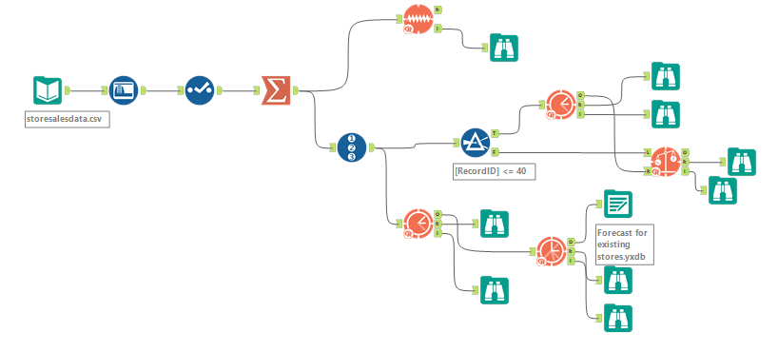

Workflow 3. Task 3: ETS model – Validation + Forecast for existing stores

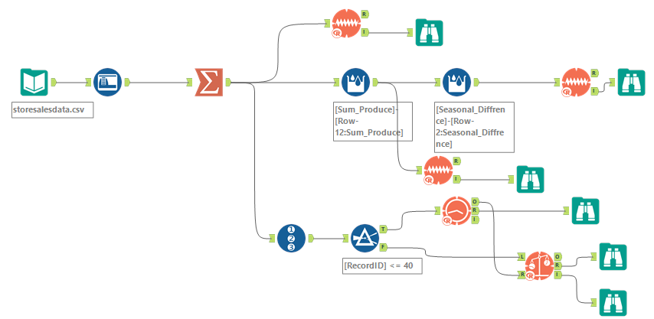

Workflow 4. Task 3: Arima model - Validation

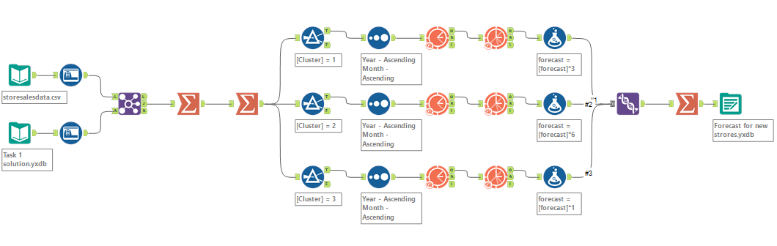

Workflow 5. Task 3: Forecast For New Stores